

LISTADO DE SEGURIDAD CATEGORIA 4

CHECK LIST – 2026
Nombre del Barco

Número de vela Teléfono Móvil a bordo

Número de personas a bordo

LUCES DE NAVEGACION FIJAS Y REPUESTO (NO PARA LED)
Rules 3.27.4 / 3.27.1 ...........................................................................................
EMISORA DE MANO VHF Rules 3.29.4
...........................................................................................
RADIO RECEPTOR PARTES METEO Rules 3.29.2
..........................................................................................
ESPICHES EN CADA PASACASCO Rules 4.03
...........................................................................................
2 EXTINTORES EN DIFERENTES UBICACIONES MÁS MANTA IGNÍFUGA Rules 4.05.3 ...........................................................................................
2 BOTES DE HUMO Rules 4.23
...........................................................................................
BOTIQUIN SANITARIO EMERGENCIA Y MANUAL DE PRIMEROS AUXILIOS
Rules 4.08 ...........................................................................................
SIRENA DE NIEBLA Rules 4.09
...........................................................................................
GPS Y SONDA Rules 4.13
...........................................................................................
REFLECTOR DE RADAR Rules 4.10.1
...........................................................................................
CARTAS NAUTICAS DE LA ZONA DE LA REGATA Rules 4.11.2
...........................................................................................
BOMBA DE ACHIQUE Rules 3.23.2

...........................................................................................

MAYOR CON RIZOS 12,5% O FOQUE TIEMPO DURO Rules 4.26.1 /4.27.1
...........................................................................................
FOQUE DE TIEMPO DURO (jib4) Rules 4.27
...........................................................................................
PÚLPITOS Y GUARDAMANCEBOS Rules 3.14
...........................................................................................
1 FONDEO COMPLETO Rule 4.06.2
...........................................................................................
ESQUEMA ELEMENTOS DE SEGURIDAD Rules 4.12
...........................................................................................
COMPAS MAGNETICO FIJO Rules 3.24
...........................................................................................
HERRAMIENTAS, RECAMBIOS Y HERRAMIENTA PARA CORTAR EL APAREJO
Rules 4.16.1 ...........................................................................................
“HEAVING LINE”, O SISGA DE 25 METROS Rules 4.22.4
...........................................................................................
CHALECOS HOMOLOGADOS, SILBATO, NOMBRE Rules 5.01
...........................................................................................
LINTERNA, NAVAJA Rules 4.25
...........................................................................................
2 CUBO CON RABIZA Rules 3.23,1
...........................................................................................
ARO SALVAVIDAS CON LUZ, SILBATO Y ANCLA DE CAPA Rules 4.22.3

….............................................................................................
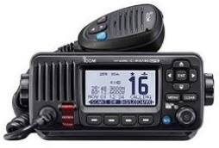
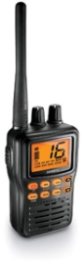
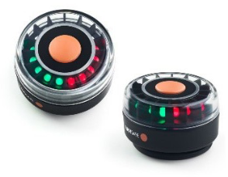
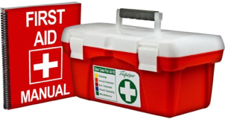
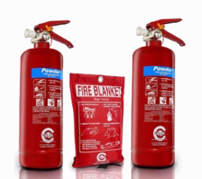
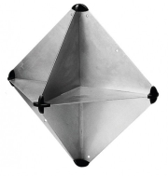
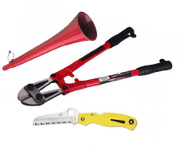
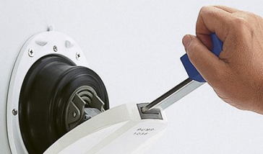
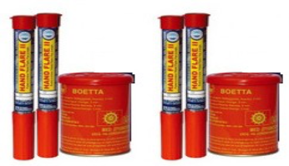

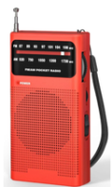


MARINE TRANSCEIVER OR VHF OSR reference 3.29.1 / 3.29.8 Marine radio transceiver with an emergency antenna when the regularantenna depends upon
the mast. If VHF min power of 25W, and,if it’s installed after 31/12/2015, be DSC capable with an assigned MMSI (unique to the boat) & connected to GPS receiver.

HAND-HELD MARINE VHF OSR reference 3.29.2
A Hand-held marine VHF transceiver, watertightorwitha waterproofcover.

NAVIGATION LIGHTS
OSR reference 3.27.1 /.2 /.3 /.4 Navigation lights mounted above sheerline, sparebulbs (not required for LED).

A SECOND RADIO RECEIVER
OSR reference 3.29.4
A second radio receiver, which maybe the handheld VHF, capable of receiving weather bulletins

SOFT TAPERED WOOD PLUGS
OSR reference 4.03
Soft tapered wood plugs attached or adjacent to every through-hull opening.

FIRSTAID MANUAL and FIRST AID KIT
OSR reference 4.08
First aid Kit & Manual (suitable for theconditions and duration of the passage.

FIRE EXTINGUISHERS FIRE BLANKET
OSR reference 4.05.1 / 4.05.03 2 fire extinguishers, ≥ 2kg, dry powder,accessible, different positions.
Fire blanket near cooking device of open flame.

RADAR REFLECTOR
OSR reference 4.10
Radar reflector: octahedral (with platescircular 12” or rectangular 16”) or of min2m2 radar cross-section.
FOGHORN / RIGGING CUTTER /KNIFE STRONG / TOOLS
OSR reference 4.09 / 4.16.1 / 4.16.2 / 4.25 Foghorn. Rigging cutter. Knife strong, securely restrained, readily accessible from the cockpit.

BILGE PUMP
OSR reference 3.23 / 3.23.1 d)
Bilge pump, manual, permanently installed, operable with all cockpit seats. Removable bilge pumps handle retained by lanyard.

BUCKETS
OSR reference 3.23.1 a)
two strong buckets, each with a lanyardand of at least 9 l (2.4 US Gal) capacity.

PYROTECHNIC SIGNALS
OSR reference 4.23 Pyrotechnicsignals:2orange smoke
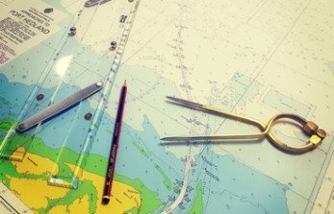

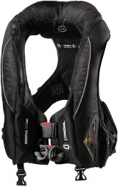
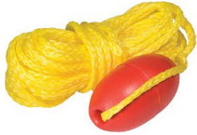
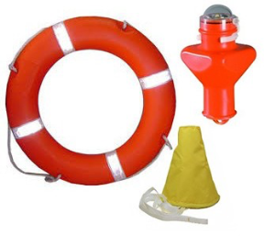

LIFEBUOY
OSR reference 4.22.3
Lifebuoy near the helmsman with self-igniting light, yacht’s name, retro-reflective material and a drogue.

CHARTS & COMPASS
OSR reference 4.11 / 3.24 a) Navigational charts and chart plotting equipment. If electronic-only, an independent alternative shall be on board
Permanently installed marine magnetic compass.

HEAVING LINE
OSR reference 4.22.7 Heavingline15-25mlong,diameter≥ 6mm,readily accessible to cockpit.

HEAVY WEATHER JIB OR REEFABLE MAINSAIL
OSR reference 4.26.2d) Either Heavy Weather Jib or
mainsail reefing to reduce the luff by at least 12.5%.

LIFE JACKET
OSR reference 5.01 / 5.01.1 a) i) / 5.01.1 a)
If manufactured before 2012 shall comply with ISO 12402 - 3 (Level 150) or equivalent, including 396 or UL 1180, if inflatable have a gas inflation system, have crotch/thighstraps (ride up prevention system (RUPS)).
If manufactured after 2011 shall comply with ISO 12402-3 (Level 150) and be fitted witha whistle, lifting loop, reflective material automatic/manual gas inflation system, crotch/thigh straps (ride up prevention system (RUPS))
have an emergency position indicating light in accordance with either ISO 12402-8 or SOLAS LSA code 2.2.3, be clearly marked with the boat’s or wearer’s name
have a sprayhood in accordance with ISO 12402-8.
A boat shall carry at least one gas inflatable lifejacket spare cylinder.

.

Nombre de la persona a carga (OSR 1.02.01)

Fecha Firma:

